S D PATEL AND ASSOCIATES

Front page

<https://www.flickr.com/photos/146141712@N06/33064100283>

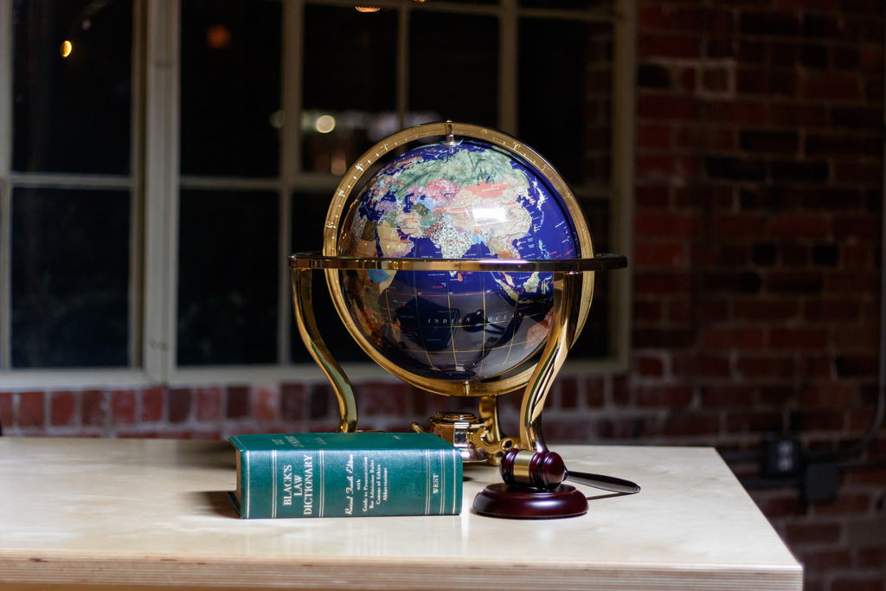

<https://pixabay.com/en/photos/law/>

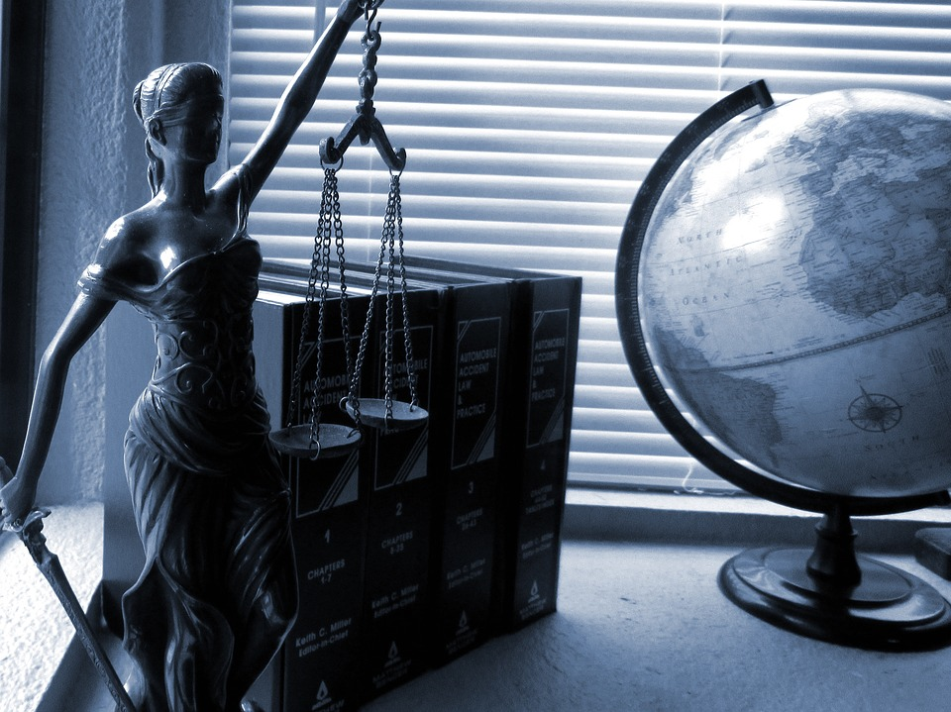

<http://faaadvogados.adv.br/novo-post-do-blog>



Commercial law

<https://pixabay.com/en/coins-gold-currency-coin-pay-431537/>

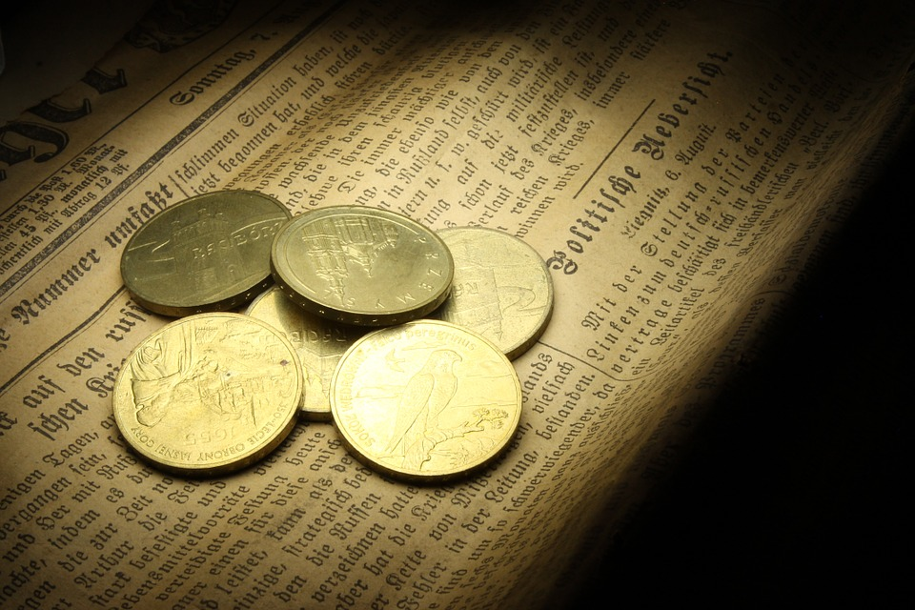

* Civil laws

https://pixabay.com/en/law-books-legal-court-lawyer-1991004/

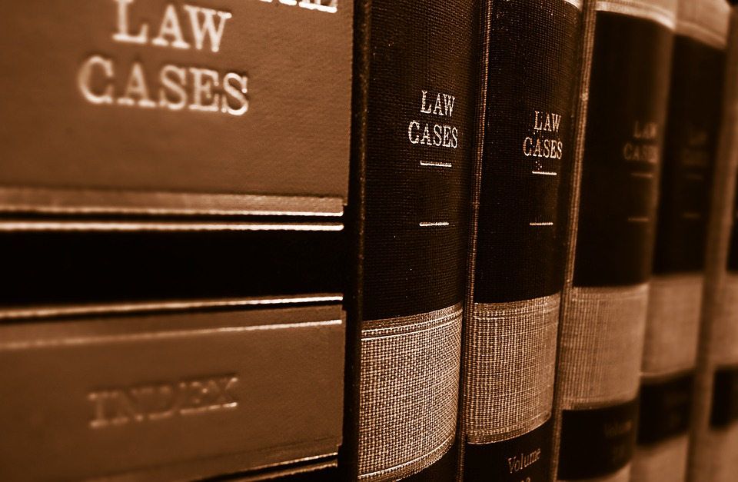

* Arbitration and Conciliation

https://www.maxpixel.net/static/photo/1x/Teamwork-Organization-Conference-Session-Meeting-2548826.jpg

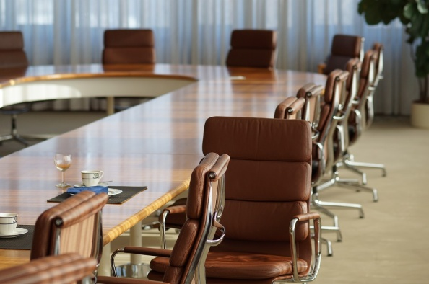

* https://www.flickr.com/photos/onepointfour/8465784739

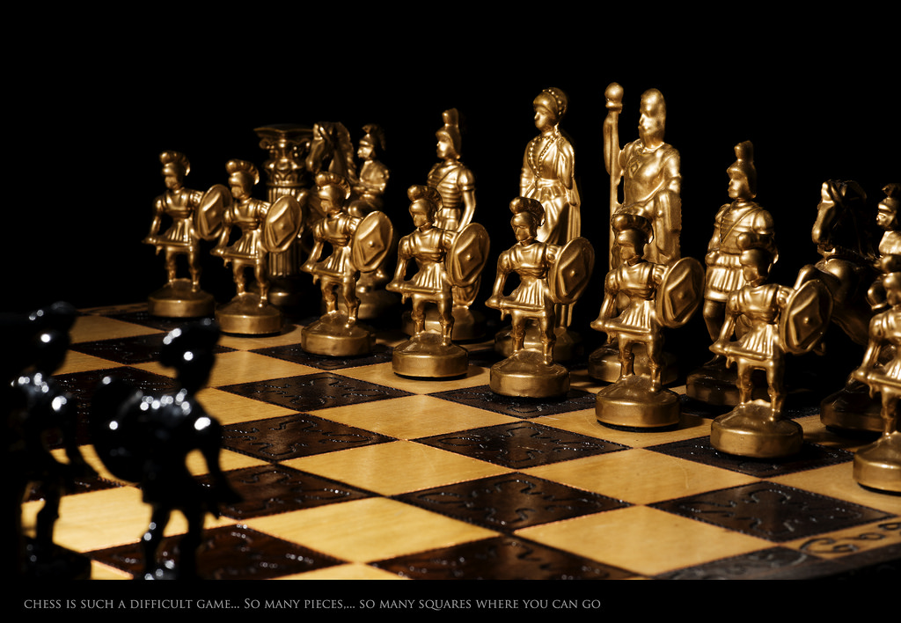

* Intellectual Property Laws

https://www.flickr.com/photos/rbabiera/17159881402

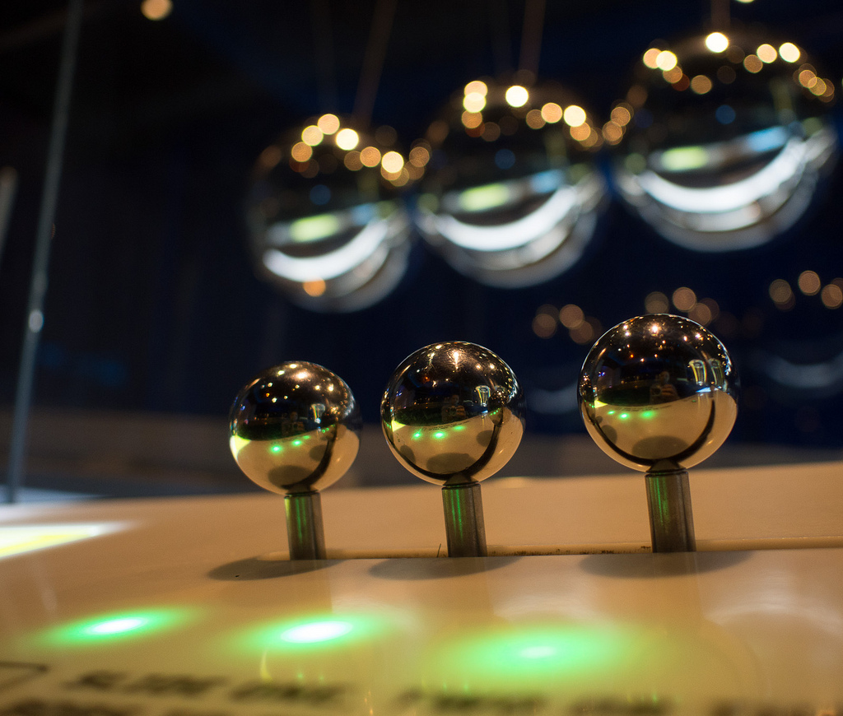

* Criminal Laws

https://torange.biz/19908.html

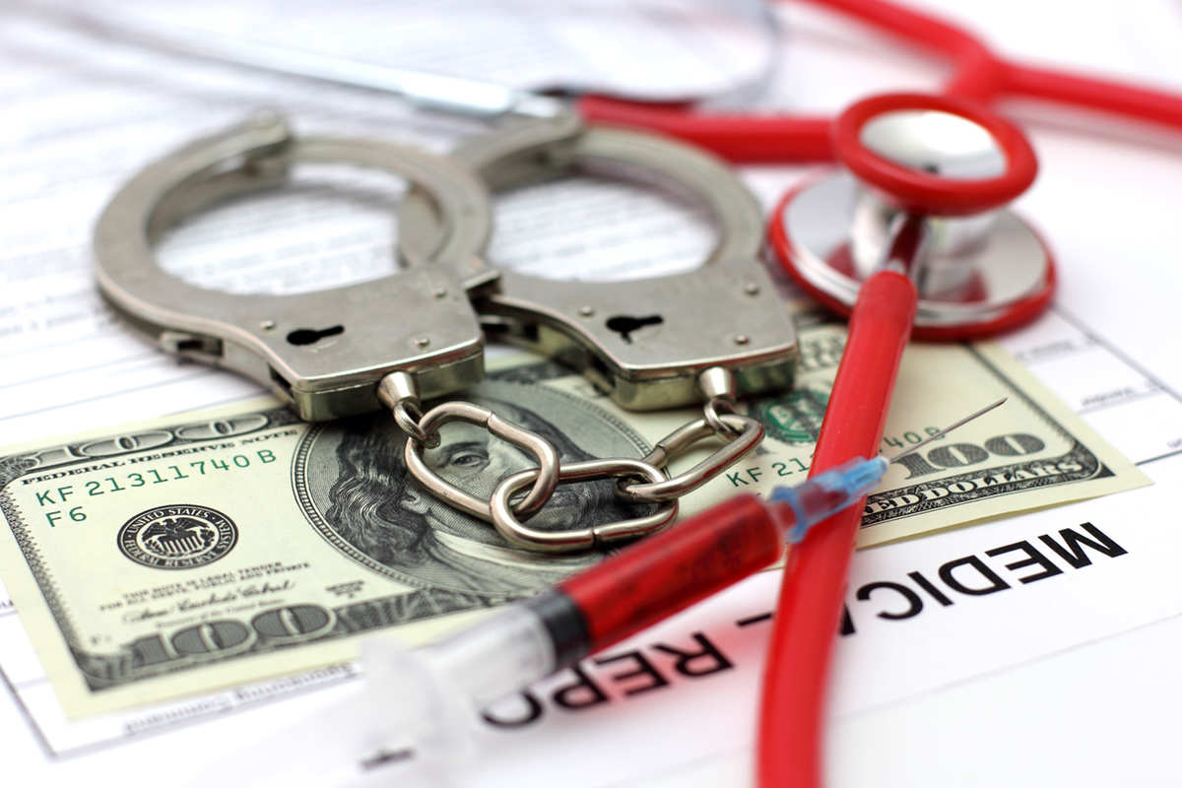

http://www.thebluediamondgallery.com/typewriter/c/crime.html

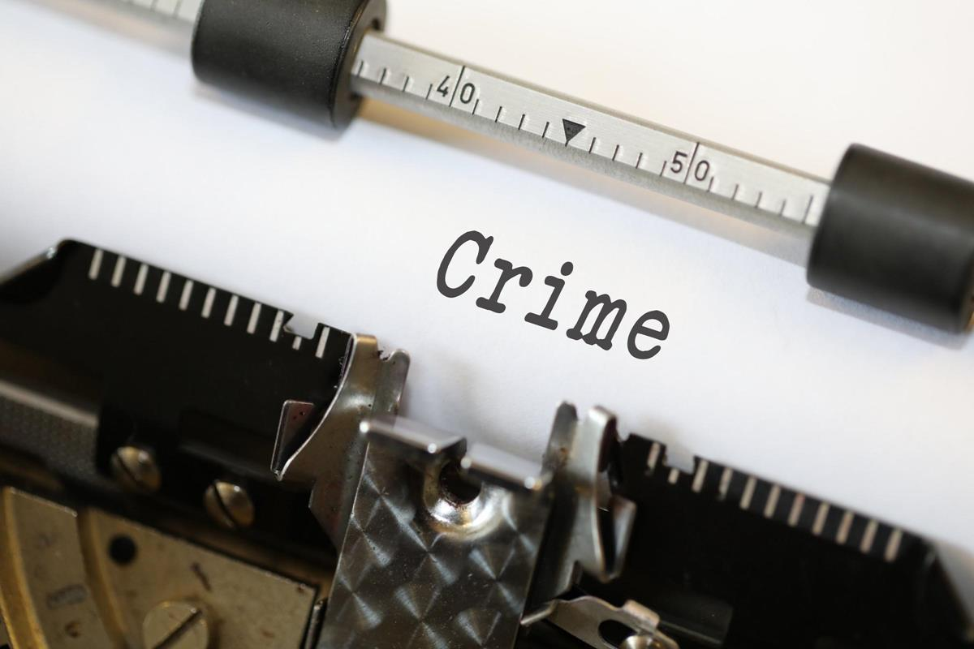+++

* Family Laws
* https://www.flickr.com/photos/128299857@N03/16026538371



https://en.wikipedia.org/wiki/Wayang_kulit

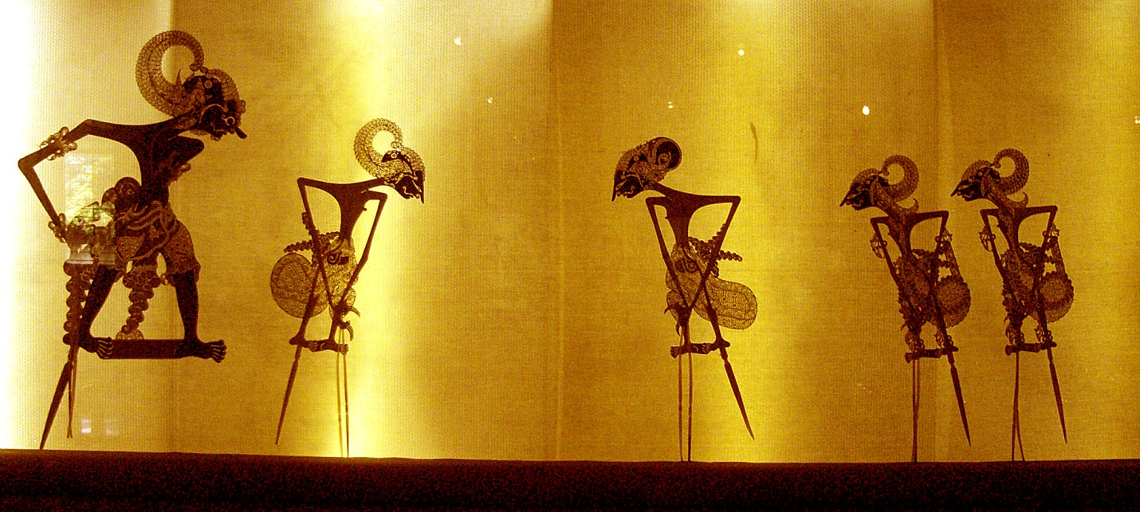

* Domestic Violence

https://pixabay.com/en/violence-against-women-1169348/



http://www.hqmc.marines.mil/Photos/?igphoto=199008

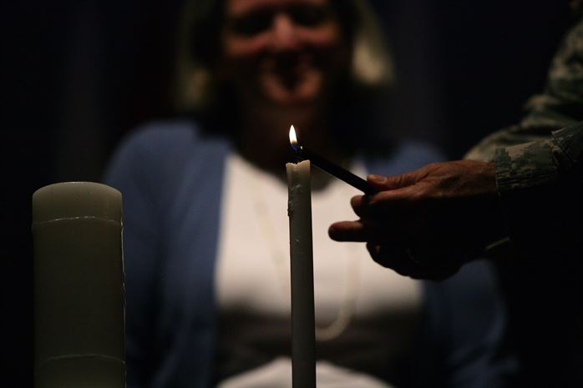

* Contracts

<http://www.thebluediamondgallery.com/typewriter/l/legal.html>

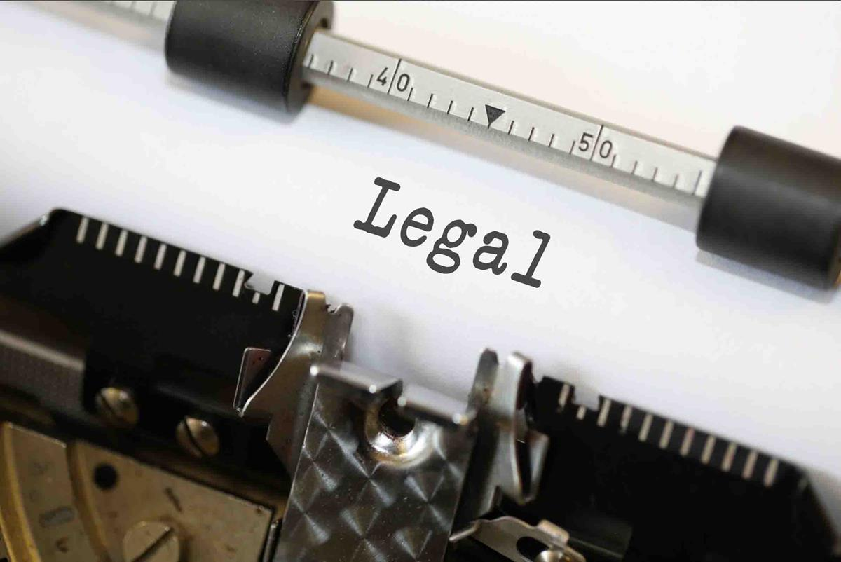

* Drafting and registration of documents
* https://en.wikipedia.org/wiki/List_of_types_of_revenue_stamps

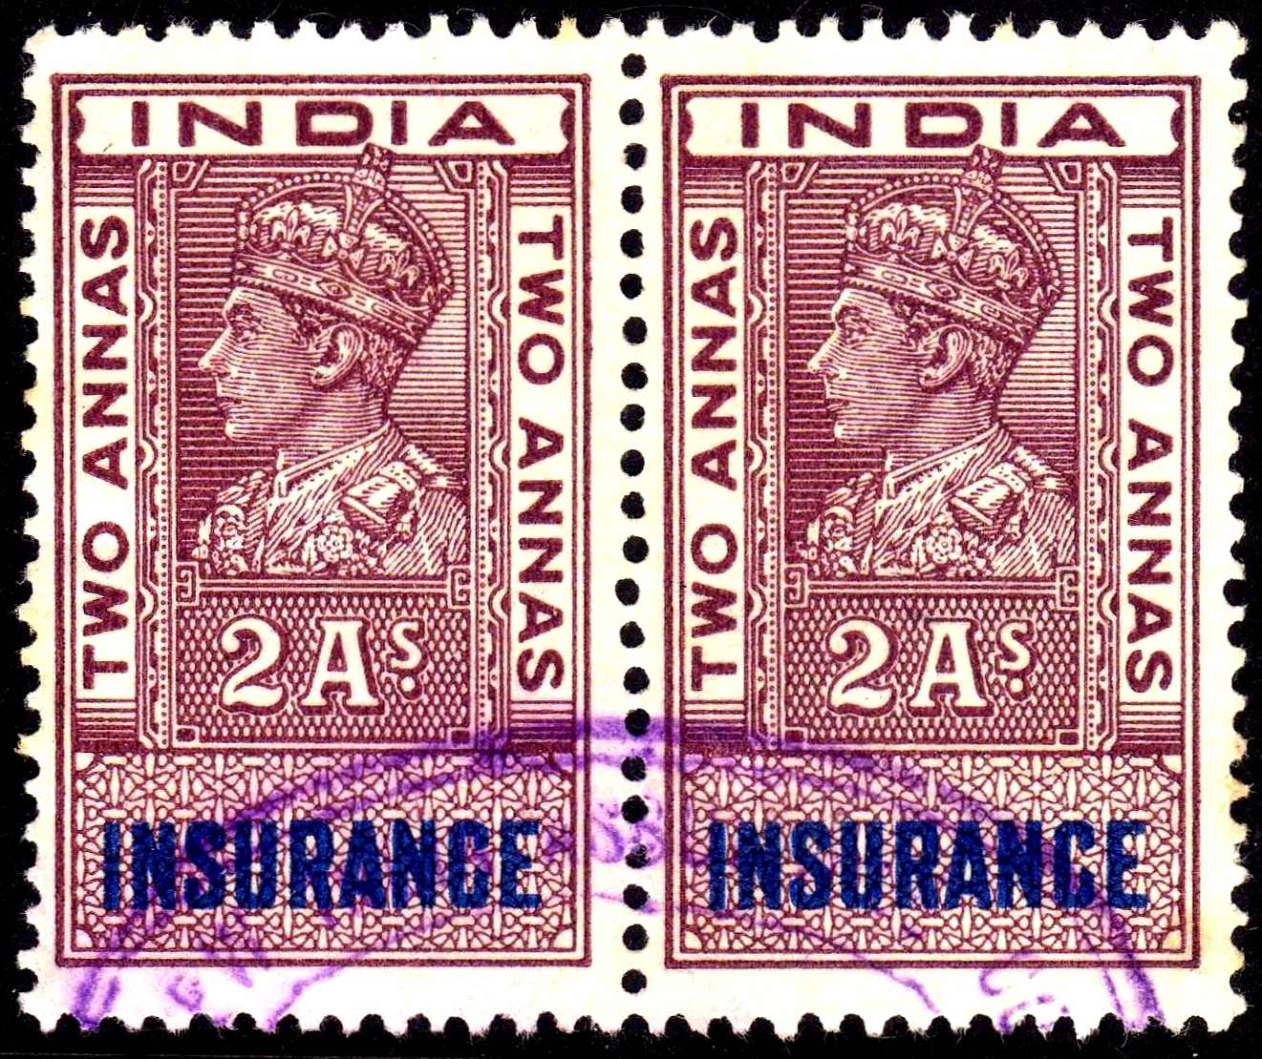

https://www.flickr.com/photos/99843102@N05/13146639633

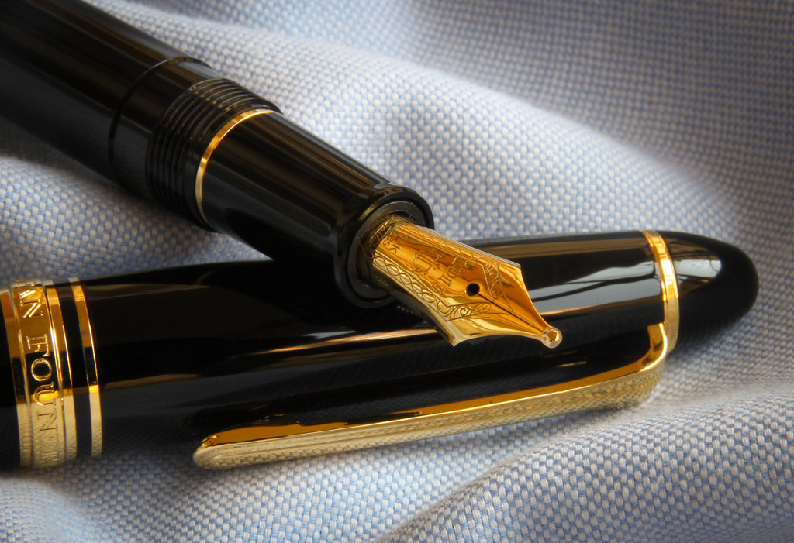

* MOU
* https://pixabay.com/en/business-composition-laptop-3365360/

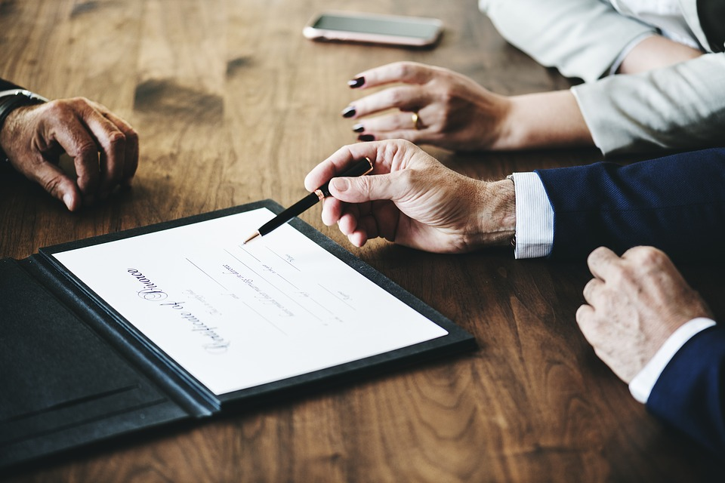

* GST and Income tax
* http://www.mountainhome.af.mil/News/Article-Display/Article/665701/beaten-to-the-punch-tax-id-fraud/

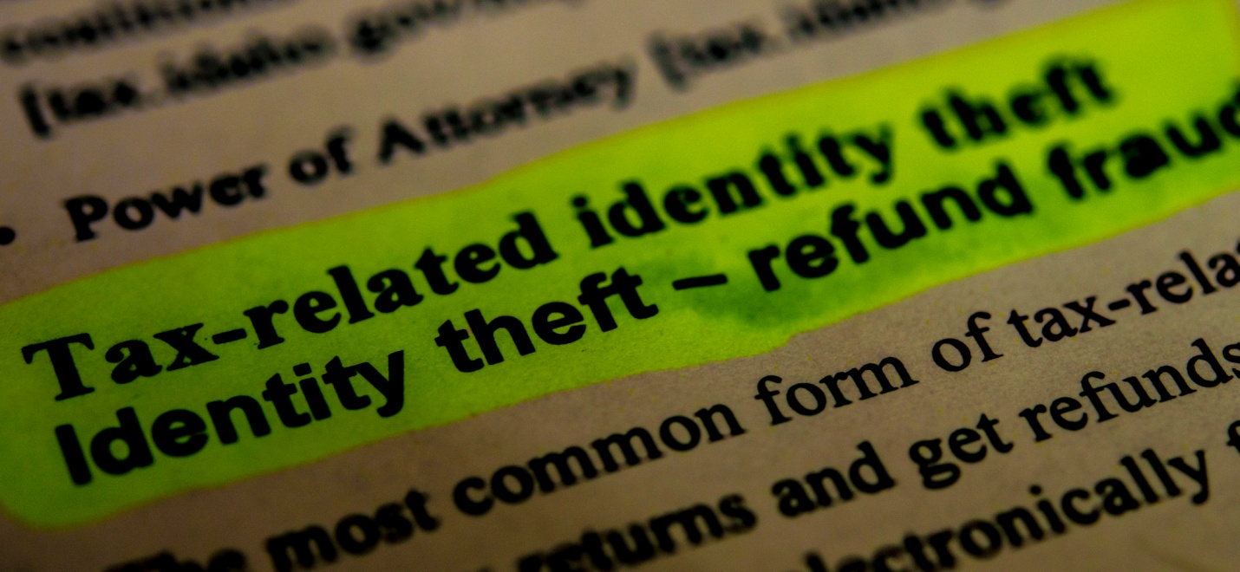

* Export And Import

https://en.wikipedia.org/wiki/Freight_transport

